DetectiveVR

Decypher the mystery in the abandoned house, but with a twist. Will you be able to?

Team members: Perju Mircea-Stefan, Hulubei Tudor, Burca Iulian Stefan

Description

1. We chose to implement this application because it involves a purpose behind the exploration. The main focus is on that.
2. The application will achieve this by setting up a story, a path to the goal and making the ending unexpected.
3. It is different from other ideas of this sort because it is the opposite of an escape room, with the main purpose being achieving to reach a certain room inside, not getting out of the building. Another different thing is having phobia elements with the main focus being on paranoia.
4. How will it go? The user starts in a forest near a house that he goes into to pursue the answer to their question. What they don’t know is that there might be someone.. or something inside (Or not? The user doesn’t know, might be their imagination) Inside the house there are clues or hidden secrets that are used into finding the answer. The story should be told in a good manner to the player to give them the motivation to reach the end and keep them engaged during the whole experience. The building is quite old and has been abandoned for a long while, yet all the answers the player finds await for them in a room upstairs. In order to be able to access it they have to find the other clues first, which will lead to a key for the door. After entering the last room there the player will find their prize, which is the explanation of the story and maybe a small surprise as well :D

Similar products & Relevant Links

**Name The Vanishing of Ethan Carter**

**Url https://store.steampowered.com/app/258520/The_Vanishing_of_Ethan_Carter/**

**Relevant Features**

- first person story-driven game (focus on exploration & discovery)

- combines horror elements with the detective aspect

- a good setup of a location and backstory, providing a good description of the situation and the purpose of the player

- communication with the dead to gain clues

- offers the user the possibility to go at their own pace, in a non-linear fashion

**Name What Remains of Edith Finch**

**Url https://store.steampowered.com/app/501300/What_Remains_of_Edith_Finch/**

**Relevant Features**

- exploration of a massive house

- mystery solving (trying to find out why they are the last alive member of their family)

- go through the story of each family member that end up with their death

**Name Alan Wake**

**Url https://store.steampowered.com/app/108710/Alan_Wake/**

**Relevant Features**

- great story telling

- mystery solving

- thrilling experience with horror elements

- atmosphere building (action game combined with psychological thriller)

**Name The Painscreek Killings**

**Url https://store.steampowered.com/app/624270/The_Painscreek_Killings/**

**Relevant Features**

- mystery investigation game

- logical puzzles

- semi-open world

-------------------------------------------------------------------------------------

Main Features

* **PRINCIPAL MAIN VERY IMPORTANT FEATURE: Story telling combined with mystery solving**
* **Other features:**
* **- paranoia elements for user engagement**
* **- hidden secrets that contribute to the story**
* **- determination to pursue the goal**
* **- exploration of the house and the rooms inside**
* **- intriguing ending**
* **- visual and audio effects to improve UX**

User Journey Diagram - Step by step flow through app

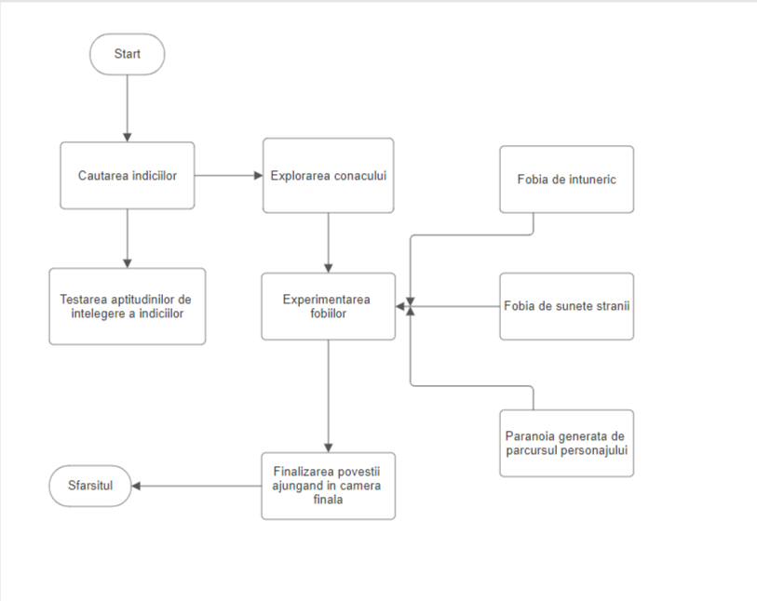

Moodboard 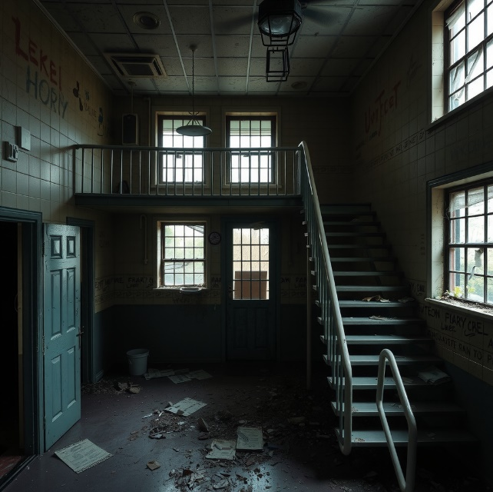

 

------------------------------------------------------------------------------------->>

Technologies, Libraries, Assets - Links

Game engine: Unity

Modelling and animations done in Blender

Might use some assets from the unity store as well.

Libraries used:

-

-